**Forces Reading Comprehension**

There are many things that move in different directions. Some things move up and down, right to left, in circles, or in many other directions. There are objects that move slowly, quickly, or in between. Some objects move on their own, and there are other objects that need help to move. No matter how something moves, whether it is an object, person, or animal, this movement is called **motion**.

Motion is movement from one place to another. For example, when two people sit on a seesaw they cause it to move up and down. One person will be in the air; the other person will be on ground level, and then they will switch places or positions. **Position** is the place where a person or object is located. If the position changes, there is motion.

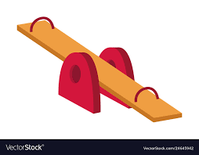The different kinds of motion include back and forth, up and down, in a circle, zig-zag, or straight ahead. Swinging on a swing is a back-and-forth motion and an up-and-down motion. Riding on a merry-go-round is going round and round in a circle. If a person is trying to avoid being tagged in a game, it might be a zig-zag motion or a straight-ahead motion.

**Questions**

1) What is the ‘movement of objects or people’ called?

2) What is the ‘place where an object is located’ called?

3) Two people are on a seesaw. How do their positions change due to their motion?

4) A person runs around a track and finishes back at the start. Describe their motion and their position.

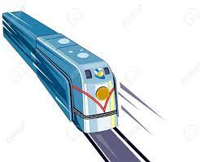In addition to different movements in motion, there is also something called **speed**. Speed is how fast a person or object moves. Speed can be very fast. For example, a train's speed moving on its tracks may be fast and straight ahead. Speed can also be very slow, like how a turtle moves from place to place. In addition, the speed of an object can be both slow and fast, like a car. Cars sometimes move slowly, but on a highway they move much faster. A car can also change direction, have different movements, and change its position very easily.

Many things that move, though, cannot move on their own. The push or pull to get an object to move is called **force**. A force is needed to get something to move. Even a person uses force to move from place to place. A person uses their muscles to help them move.

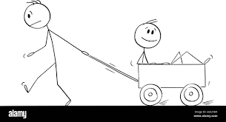When a person moves a cart, it is an example of pulling. When a person opens a door, it can be an example of pulling or pushing. When a person wakes up in the morning, they may use their legs to push their body out of the bed. Opening a drawer is another example of pulling, and while eating something the teeth and tongue push and pull on the food. While cleaning dishes or washing a car a person usually pushes a cloth and applies force to remove the dirt.

**Questions**

1) What causes things to move?

2) Using the text, list three examples of a force?

3) How do you think the speed of an object would change if the force on it increases? Give an example to explain your reasoning.